This Application is used for get holiday lists. Application add holiday calendar list for each country from Below web address
https://www.officeholidays.com/ics/{country_name}
like https://www.officeholidays.com/ics/malaysia
Application Image
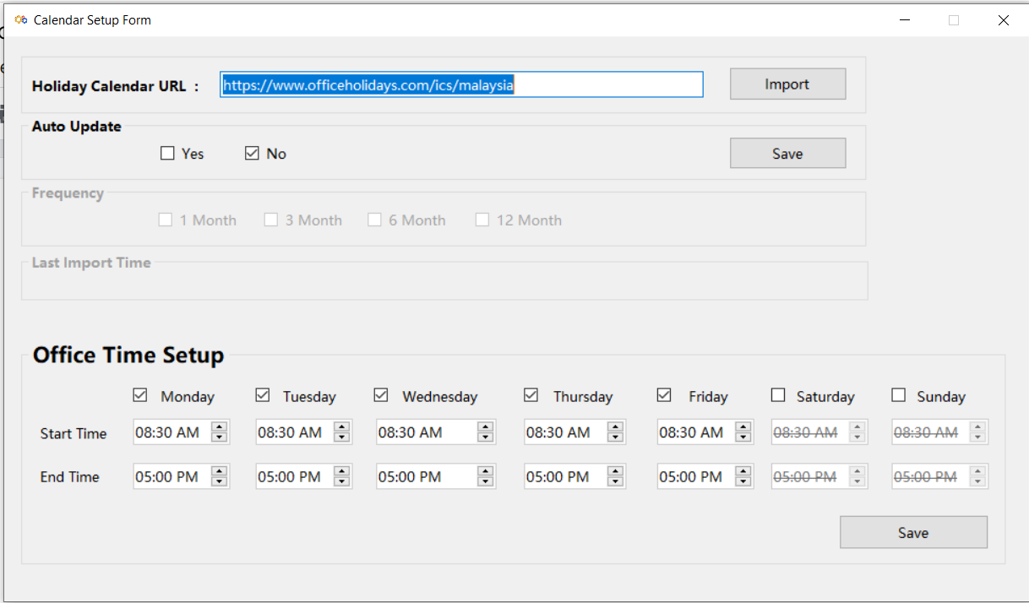

Holiday Calendar URL: For import holiday lists from URL in Database.
Auto Update: Auto update holiday list from URL, if enabled.

Frequency: Auto update frequency. Auto update lists after
every 1, 3, 6, & 12 months.

Last import time: Time of last imports holiday list.

Office time setup: Change office time as per needed.

How to install:
Step 1: Run below sql script in Database [Sql Server]
USE [DB_NAME]
GO
/****** Object: Table [dbo].[GBL_HOLIDAY] Script Date: 3/30/2022 1:17:55 PM ******/
SET ANSI_NULLS ON
GO
SET QUOTED_IDENTIFIER ON
GO
CREATE TABLE [dbo].[GBL_HOLIDAY](
[HOLIDAY_ID] [int] IDENTITY(1,1) NOT NULL,
[HOLIDAY_DATE] [datetime] NOT NULL,
[HOLIDAY_DESC] [nvarchar](max) NULL,
[IS_ACTIVE] [bit] NOT NULL,
[ORG_ID] [int] NULL,
[CREATED_BY] [int] NULL,
[CREATED_ON] [datetime] NULL,
[LAST_MODIFIED_BY] [int] NULL,
[LAST_MODIFIED_ON] [datetime] NULL,
CONSTRAINT [PK_dbo.GBL_HOLIDAY] PRIMARY KEY CLUSTERED
(
[HOLIDAY_ID] ASC
)WITH (PAD_INDEX = OFF, STATISTICS_NORECOMPUTE = OFF, IGNORE_DUP_KEY = OFF, ALLOW_ROW_LOCKS = ON, ALLOW_PAGE_LOCKS = ON, OPTIMIZE_FOR_SEQUENTIAL_KEY = OFF) ON [PRIMARY]
) ON [PRIMARY] TEXTIMAGE_ON [PRIMARY]
GO
/****** Object: Table [dbo].[GBL_OFFICETIME] Script Date: 3/30/2022 1:17:55 PM ******/
SET ANSI_NULLS ON
GO
SET QUOTED_IDENTIFIER ON
GO
CREATE TABLE [dbo].[GBL_OFFICETIME](
[DAY_ID] [int] IDENTITY(1,1) NOT NULL,
[DAY_NAME] [nvarchar](50) NULL,
[START_TIME] [time](7) NULL,
[END_TIME] [time](7) NULL,
[ORG_ID] [int] NULL,
[IS_ACTIVE] [int] NULL,
[CREATED_BY] [int] NULL,
[CREATED_ON] [datetime] NULL,
[LAST_MODIFIED_BY] [int] NULL,
[LAST_MODIFIED_ON] [datetime] NULL,
CONSTRAINT [PK_GBL_OFFICETIME] PRIMARY KEY CLUSTERED
(
[DAY_ID] ASC
)WITH (PAD_INDEX = OFF, STATISTICS_NORECOMPUTE = OFF, IGNORE_DUP_KEY = OFF, ALLOW_ROW_LOCKS = ON, ALLOW_PAGE_LOCKS = ON, OPTIMIZE_FOR_SEQUENTIAL_KEY = OFF) ON [PRIMARY]
) ON [PRIMARY]
GO
SET IDENTITY_INSERT [dbo].[GBL_OFFICETIME] ON

INSERT [dbo].[GBL_OFFICETIME] ([DAY_ID], [DAY_NAME], [START_TIME], [END_TIME], [ORG_ID], [IS_ACTIVE], [CREATED_BY], [CREATED_ON], [LAST_MODIFIED_BY], [LAST_MODIFIED_ON]) VALUES (1, N'MONDAY', CAST(N'08:30:00' AS Time), CAST(N'17:00:00' AS Time), 0, 1, NULL, NULL, NULL, NULL)
INSERT [dbo].[GBL_OFFICETIME] ([DAY_ID], [DAY_NAME], [START_TIME], [END_TIME], [ORG_ID], [IS_ACTIVE], [CREATED_BY], [CREATED_ON], [LAST_MODIFIED_BY], [LAST_MODIFIED_ON]) VALUES (2, N'TUESDAY', CAST(N'08:30:00' AS Time), CAST(N'17:00:00' AS Time), 0, 1, NULL, NULL, NULL, NULL)
INSERT [dbo].[GBL_OFFICETIME] ([DAY_ID], [DAY_NAME], [START_TIME], [END_TIME], [ORG_ID], [IS_ACTIVE], [CREATED_BY], [CREATED_ON], [LAST_MODIFIED_BY], [LAST_MODIFIED_ON]) VALUES (3, N'WEDNESDAY', CAST(N'08:30:00' AS Time), CAST(N'17:00:00' AS Time), 0, 1, NULL, NULL, NULL, NULL)
INSERT [dbo].[GBL_OFFICETIME] ([DAY_ID], [DAY_NAME], [START_TIME], [END_TIME], [ORG_ID], [IS_ACTIVE], [CREATED_BY], [CREATED_ON], [LAST_MODIFIED_BY], [LAST_MODIFIED_ON]) VALUES (4, N'THURSDAY', CAST(N'08:30:00' AS Time), CAST(N'17:00:00' AS Time), 0, 1, NULL, NULL, NULL, NULL)
INSERT [dbo].[GBL_OFFICETIME] ([DAY_ID], [DAY_NAME], [START_TIME], [END_TIME], [ORG_ID], [IS_ACTIVE], [CREATED_BY], [CREATED_ON], [LAST_MODIFIED_BY], [LAST_MODIFIED_ON]) VALUES (5, N'FRIDAY', CAST(N'08:30:00' AS Time), CAST(N'17:00:00' AS Time), 0, 1, NULL, NULL, NULL, NULL)
INSERT [dbo].[GBL_OFFICETIME] ([DAY_ID], [DAY_NAME], [START_TIME], [END_TIME], [ORG_ID], [IS_ACTIVE], [CREATED_BY], [CREATED_ON], [LAST_MODIFIED_BY], [LAST_MODIFIED_ON]) VALUES (6, N'SATURDAY', CAST(N'08:30:00' AS Time), CAST(N'12:30:00' AS Time), 0, 1, NULL, NULL, NULL, NULL)
INSERT [dbo].[GBL_OFFICETIME] ([DAY_ID], [DAY_NAME], [START_TIME], [END_TIME], [ORG_ID], [IS_ACTIVE], [CREATED_BY], [CREATED_ON], [LAST_MODIFIED_BY], [LAST_MODIFIED_ON]) VALUES (7, N'SUNDAY', CAST(N'08:30:00' AS Time), CAST(N'00:30:00' AS Time), 0, 0, NULL, NULL, NULL, NULL)
SET IDENTITY_INSERT [dbo].[GBL_OFFICETIME] OFF
GO
ALTER TABLE [dbo].[GBL_HOLIDAY] ADD CONSTRAINT [DF_dbo.GBL_HOLIDAY_IS_ACTIVE] DEFAULT ((1)) FOR [IS_ACTIVE]
GO

Step 2: Create belows column in the GBL_ENV table.
alter table [dbo].[GBL_ENV] ADD CALENDAR_URL NVARCHAR(MAX) NULL
alter table [dbo].[GBL_ENV] ADD AUTO_UPDATE BIT NOT NULL DEFAULT 0
alter table [dbo].[GBL_ENV] ADD FREQUENCY INT NOT NULL DEFAULT 0
alter table [dbo].[GBL_ENV] ADD LAST_UPDATE_TIME datetime NULL

Step 3: Run Holiday Calendar Setup file. [Download Link]
By default application install path is “C:\Program Files (x86)\Miracle Advance\HolidaySetup”
Step 4: Configure Database from CalendarApp.exe.config file. Path is application install-
path and Change the connectionString as needed.
Ex: Data Source=BMCMIRISYNRIS;Initial Catalog=RIS_BORNEOMINI;User Id=name;Password=123;
Data Source=MAHADI-ADT; Initial Catalog=RIS_KLGSH; Integrated Security=True;

<connectionStrings>
<add name="DbConnection"
providerName="System.Data.SqlClient"
connectionString="Data Source=MAHADI-ADT; Initial Catalog=DB_NAME; Integrated Security=True;" />
</connectionStrings>
Successfully install

Now you can Import a calendar list in Database by using the link as mentioned before.

